Enrollment Features
- Customer Programs Enrollment Center (EC) Framework
- Standalone Enrollment Center for the existing customers.
- EC Integration with Contract Management ( Move-in Process, Change Contracts)

Enrollment Center UI has four main component

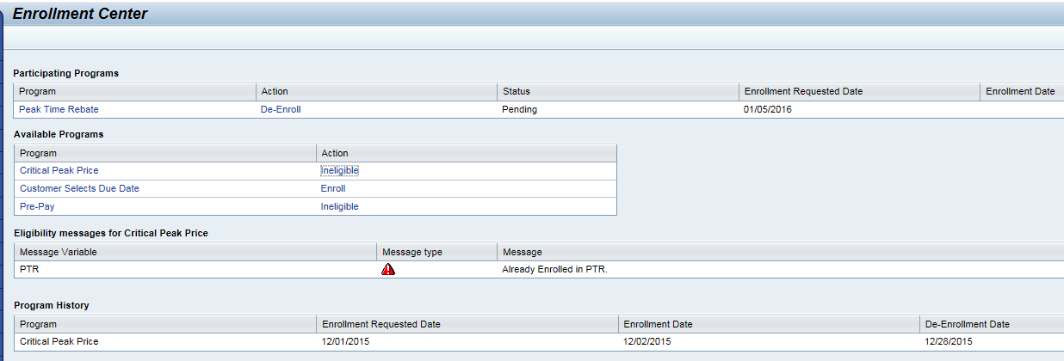
    - Participating Program
      - All enrolled programs listed, with a one-click button to de- enroll, following de-enrollment step or prompts.
      - Enrollment Status:- possible statuses ex:- Enrollment Request Enrollment Pending, Enrollment Cancelled
      - Enrollment request date and Actual Program enroll date
    - Available Program
      - Hyperlinks provide one-click access the program information.
      - Hyperlinks provide one-click access to enroll, following enrollment step.

    - Eligibility Messages
      - More customer- specific eligibility details (ex:-de- enrollment from another program).
    - Program History
      - Enrollment History can be maintained, to build process/ system eligibility rules.
